Development of an Android Controlled Crop Dusting Hexacopter UAV

J.R. Del Rosario*, P.R. Aquino , D.M. dela Cruz , K.S. Teves , J.A. Trinidad and K.R. Villavecer
Electronics and Communications Engineering Department, Gokongwei College of Engineering, De La Salle University-Manila, 2401Taft Ave., Malate, Manila 1004, Philippines
* jay.delrosario@dlsu.edu.ph
Keywords: Crop Dusting; Hexacopter; UAV; Zigbee Technology
Introduction
Chemical fertilizers usually contain ammonia, nitrogen phosphorus and other chemicals that are harmful when contacted or exposed to humans for a long period of time(Havlin, et al 2005). To avoid such problems, modern technologies such as crop dusting UAVs are used to eliminate direct contact with chemical fertilizers. These drones also make the application easier and faster.
Over-fertilization of soils used for agricultural purposes is a growing environmental concern. Remaining or excess fertilizers can also become a waste, thus Hexacopter can aid in waste management of fertilizers with no human contacts or exposure to harmful chemicals. This project also studies the optimum nutrient level or amount of fertilizer to be applied in a garden or farm to avoid over-fertilization and too much compost applied to soils.
Commercially available UAVs are usually expensive and used on a much larger scale of agricultural land having different terrains (Valavanis 2008). An agricultural country, like the Philippines, would benefit on such advancement of technology, but ordinary farmers cannot afford such expensive machineries. Therefore, there is a need for cheaper but still reliable crop dusting UAVs.
This paper presents the design considerations implemented in order to create cost-efficient crop dusting Hexacopter. For this specific prototype, the drone must be able to lift a maximum 2kg payload of liquid with the maximum height of 5ft. To build a durable and lightweight drone, carbon fiber material and aluminium steel were used. Additionally, Hexacopter was chosen instead of a quadrotor so that more thrust can be produced. Thus, more load can be carried. To control the Hexacopter, Android application was used with the implementation of Zigbee technology as its means of communication.
Different tests were also done to determine its flight and spray performance. The Hexacopter flight movements were tested having different weights to examine its carrying capacity as well as its flight behaviour. The signal and range of the Android and Hexacopter were also tested for different distances. Material and Methods

Results and Conclusions
The efficiency and functionality of the Hexacopter was evaluated through different tests. An altitude test was conducted in order to check if the system is capable of lifting a payload of 2Kg at 5 feet. The battery’ s capability was tested as seen in Figures 1.1-1.3,during hover state and while performing actual movements. Through these types of tests, the average flight time of the Hexacopter was determined as well as its range of operability. In order to assure that the users are safe an emergency landing was implemented so whenever the specified range of operability was not followed the system would automatically land when it reaches a predefined voltage.
The overall test examines the ability of the Hexacopter to navigate properly and perform all of its functions at the same time. The test was done in a 100 square meter open area following a zigzag pattern in order to optimize flight time. The Hexacopter was able to complete the course while initially carrying a 2Kg liquid in 3ft and 5ft as seen in Figure 1.4. The battery performance test would allow the researchers to see the consistency of the battery and the time it takes for it to be consumed. As the Hexacopter hovers at 5ft, ten trials were done wherein for each trial, the time was recorded from the highest possible voltage until the battery was discharged. The first set of trials indicate the time it takes the battery to be discharged without load. On the other hand, the second trial shows the time when the Hexacopter has a payload of 2kg. The battery life lasts for about 11-13 mins without load and 8-10 mins with load. Furthermore, the tests with no load shows that it has longer flight time since it has lesser weight while the tests with 2kg load has shorter flight time than that of the tests without load. This shows that the weight of the Hexacopter greatly affects the duration of its flight and consumption of its battery.
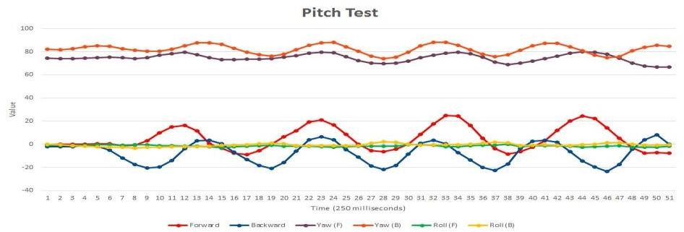
Figure 1.1 Pitch Test of Hexacopter
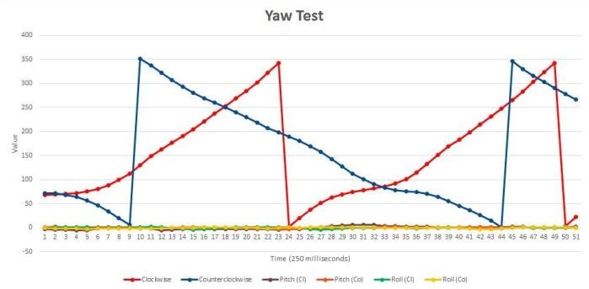

Figure 1. 2 Yaw Test of Hexacopter

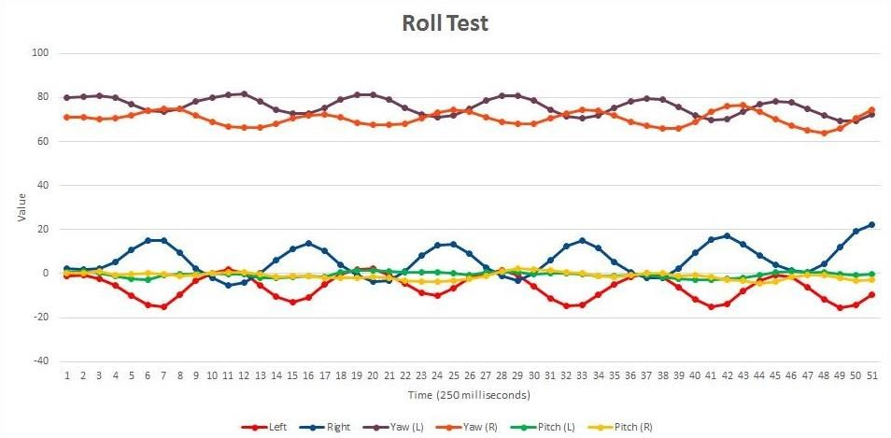

Figure 1.3 Roll Test of Hexacopter
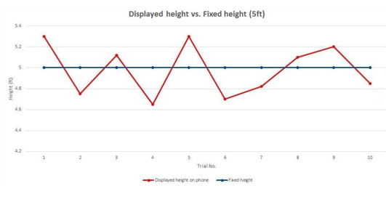
Figure 1.4 Altitude Test of Hexacopter for 5ft

Present day technologies that are used in applying fertilizers are crop dusting aircrafts and UAVs. With continuous research on the matter, the researchers were able to develop an Android controlled crop dusting UAV that only costs 1/16th the average amount of the commercially available Agricultural UAVs today; still maintaining the efficiency and benefits of using such technologies. This method results in less effort and time consumed in crop dusting. To evaluate the Hexacopter’ s efficiency and functionality, different tests such as flight, altitude and range tests were conducted. The Hexacopter was able to perform its different movements and functions, such as take-off, land and spray, with and without its max payload of 2Kg at a range of at least 200m. To ensure the user’ s ability to navigate the Hexacopter back and forth its initial position as its battery discharges, a low voltage mechanism was implemented. It is responsible for sending alerts to the user at different battery levels. Through testing, the average discharge rate of the battery with and without a 2Kg payload was determined. With that information, the user acquired knowledge on the amount of distance that can be covered by the Hexacopter at a certain battery level, given the alerts of the low voltage mechanism.
References
Agency for Toxic Substances and Disease Registry, “Public health statement for ammonia,” September 2004. [Online]. Available: http://www.atsdr.cdc.gov/phs/phs.asp?id=9tid=2

Artale, V., Milazzo, C., and Ricciardello, A.(2013), "Mathematical Modeling of Hexacopter." Applied Math and Science Journal 7.97 (2013): 4805-4811.

Dos Santos, D., Saotome, O., and Cela, A. (2013) "Trajectory Control of Multirotor Helicopters with Thrust Vector Constraints." Control & Automation (MED), 2013 21st Mediterranean Conference IEEE.

Havlin, J. L., et al. Soil Fertility and Fertilizers: An Introduction to Nutrient Management. Vol. 515. Upper Saddle River, NJ: Pearson Prentice Hall, 2005.

Valavanis,K.(2008), Unmanned Aircraft Systems : International Symposium on Unmanned Aerial Vehicles, UAV’08. Dordrecht London: Springer.

